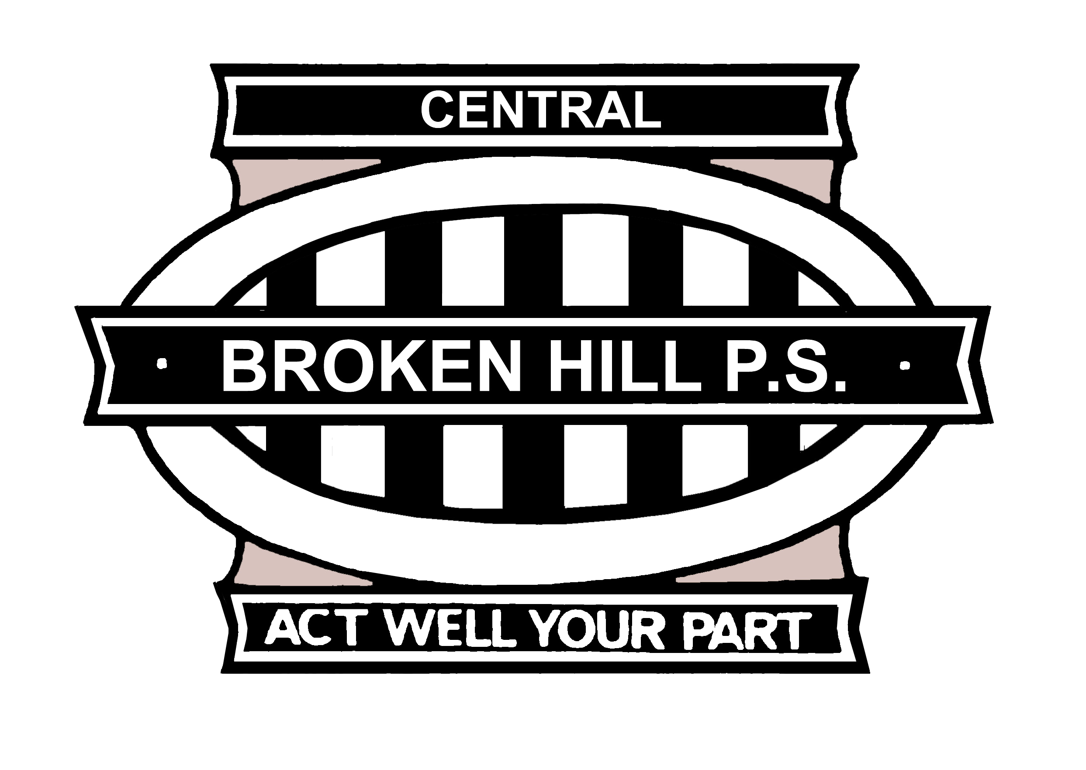
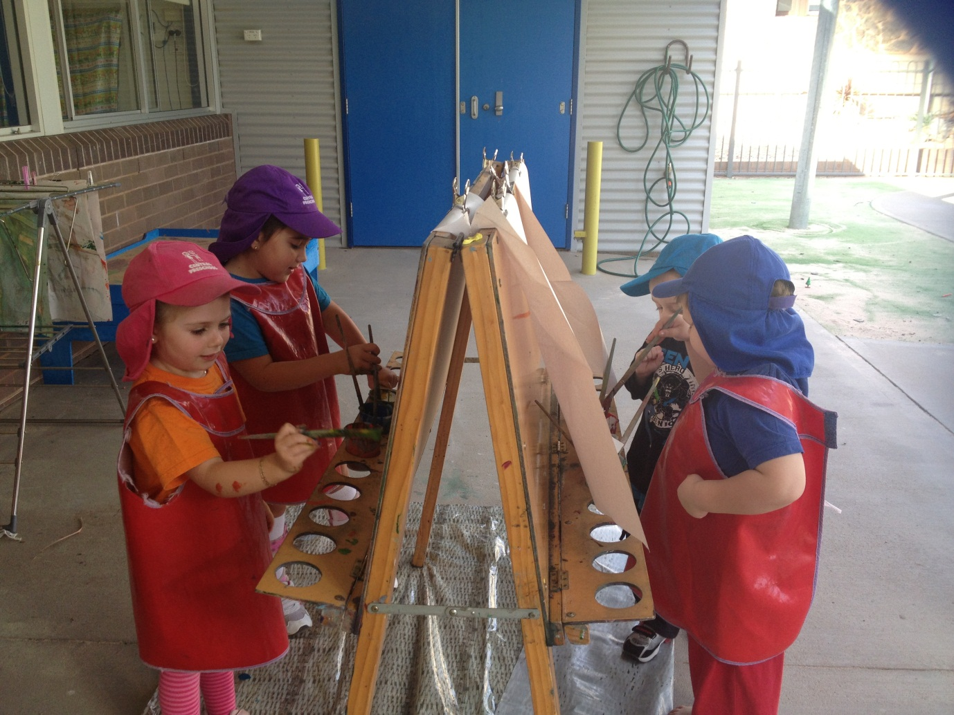
Broken Hill Public School Preschool
Mica Street
PO Box 33
Broken Hill NSW 2880
Phone (08) 8087 3522
Fax (08) 8087 3903
Welcome
to
Central
Pre School

We care, we share, we love to learn.
2014 Preschool Session Times

Session One (2 ½ days)

Monday 8.45 am - 2.50 pm
Tuesday 8.45 am – 2.50 pm
Wednesday 8.45 am – 11.35 am

Session Two (2 ½ days)

Wednesday 12.00 pm – 2.50 pm
Thursday 8.45 am – 2.50 pm
Friday 8.45 am – 2.50 pm

Thus ensures access is fair and even to all children over the year, averaging 15 hours per week.

Broken Hill Public School Preschool

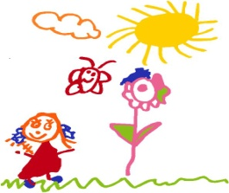
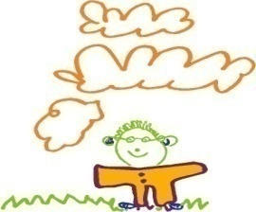
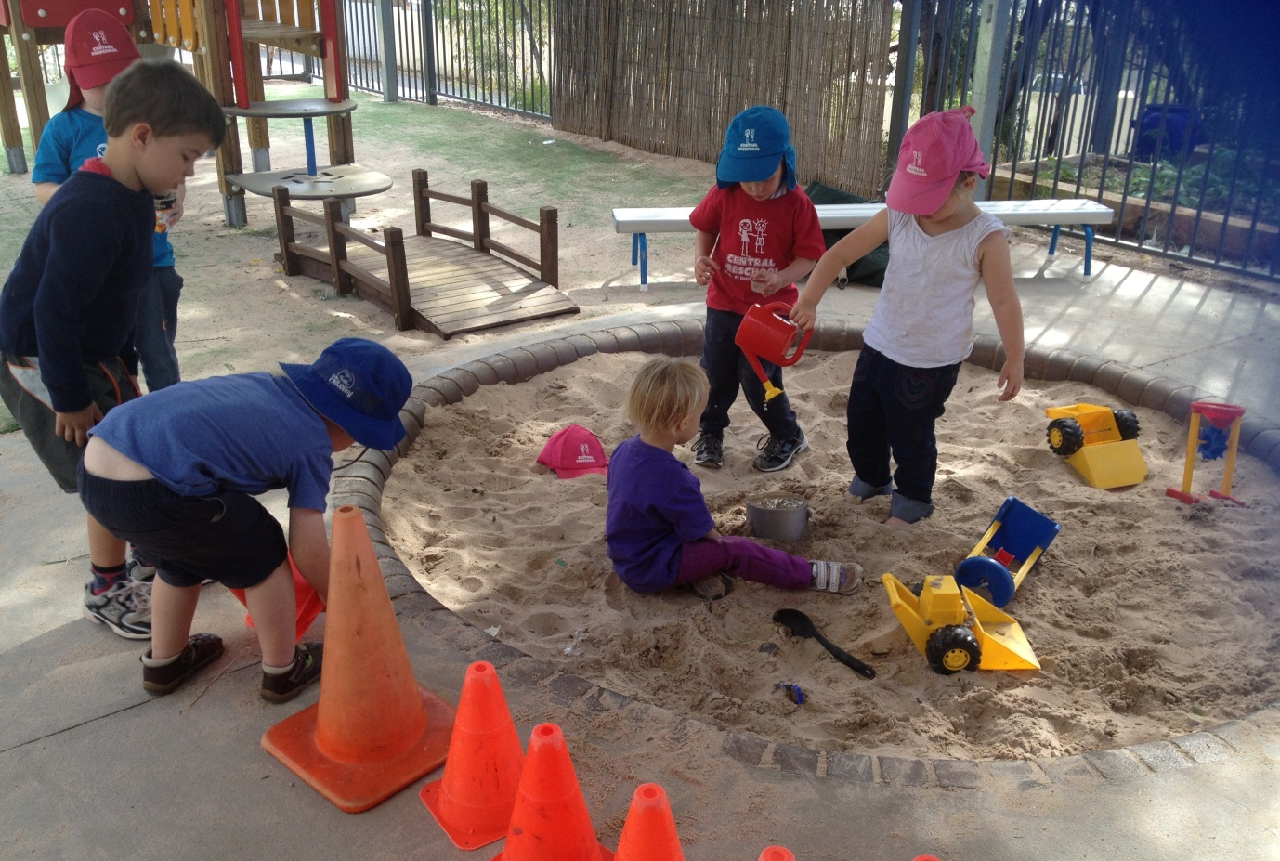
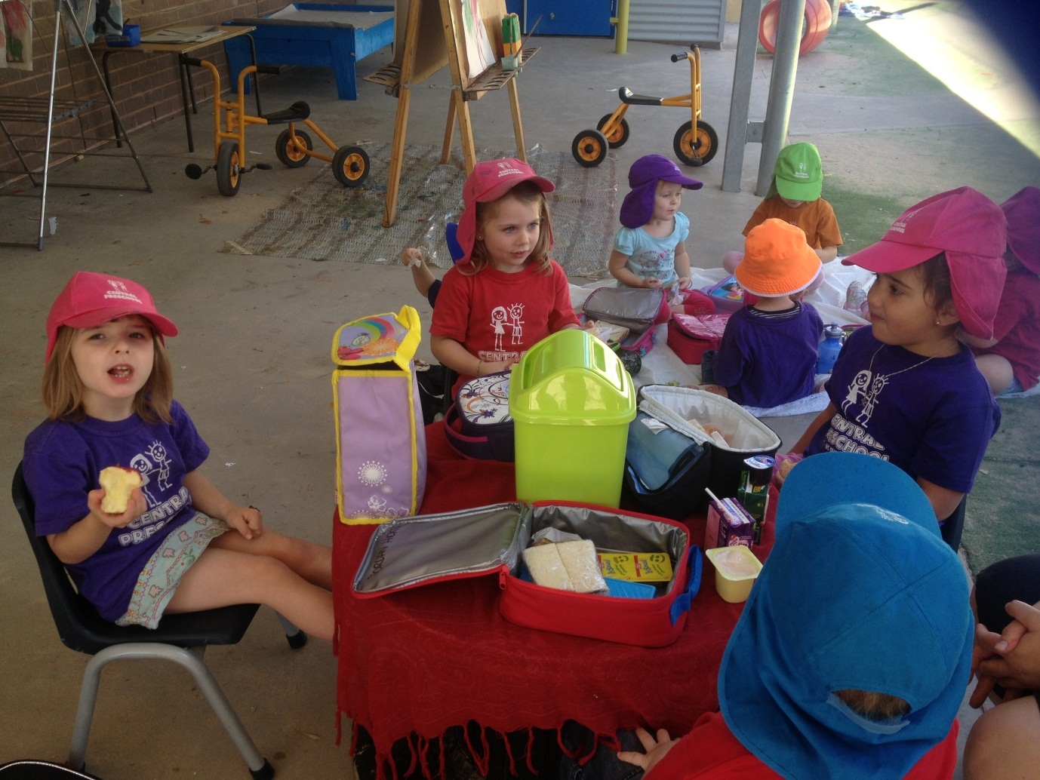
Contact us at
8087 3522
or look us up on the internet at
www.brokenhillpublicschool.com.au

If you are interested in our Preschool please call into the Administration Office and collect a waiting list application form.

You can also arrange a time for a ‘look’ at the program in progress with the school office.

Waiting list application forms will be available until Friday 13th September 2013.

Our Principles, Practice and Outcomes

The Australian government has introduced the new National Quality Framework for Early Childhood Education and Childcare. The framework puts in place a new National Quality Standard across Australia. The National Quality Framework has 3 parts:
- the National Quality Standard;
- a national quality rating system with 5 levels including a quality rating for 7 key areas of childhood development; and
- the Early Years Learning Framework (EYLF).
We also ensure all staff working within our preschool adhere to the Early Childhood Australia Code of Ethics.

We follow the Early Years Learning Framework (EYLF) and National Early Childhood Quality Standard Principles, Practices and Outcomes for the Early Years.

The five principles, which underpin our practice, are:

- secure, respectful and reciprocal relationships with children and families;
- partnerships with children, families, primary school and other professionals;
- high expectations and equity;
- respect for diversity; and
- ongoing learning and reflective practice.

Our Preschool Program: 3¹/₂ - 5 year olds

Our Preschool operates Monday to Friday with 2 alternate programs. Your child will be offered the program most suited to their needs and with consideration of family preferences wherever possible.

Our program follows the National Early Years Learning Framework (EYLF) which has a strong emphasis on play-based learning. The framework recognises the importance of communication and language (including early literacy and numeracy) and social and emotional development.

The staff work to nurture children’s creative intellect providing many opportunities for open-ended play and scientific endeavour. Our classroom and outdoor environment are welcoming, inclusive and well organised spaces. The learning centres are carefully arranged to promote active learning and are based on both intentional and play based learning outcomes. Our program allows for flexibility and is based on the children’s emerging interests in all curriculum areas.

Play is seen as a powerful medium for learning and development. It acknowledges the child as capable and resourceful encouraging independence and improved sense of confidence.

Preschool Fees

The NSW government operates preschool classes in 100 government schools. From 2012, all government preschools have had a daily fee. All parents/carers are required to pay a fee for attendance. The full daily fee for our preschool class/es set by the NSW government is $15.00 a day. The policy clearly states that low income families (as determined by a current Commonwealth Health Care or Pension Cards) are eligible for fee relief at the daily rate of $7.00, Aboriginal or Torres Strait Islanders are also entitled to a fee relief of $4.00 per day. You can pay weekly, fortnightly, monthly or termly. The school will send an invoice to you, at the beginning of each term.

Under the policy, fee relief and fee exemption are always available. If you wish to discuss your family’s situation, it is important that you make the time to contact Mr Fisher, to talk about any concerns you may have about your eligibility for fee relief or reduction. The policy clearly states that no child will be excluded from preschool in a public school because of the financial circumstances of their family.



