
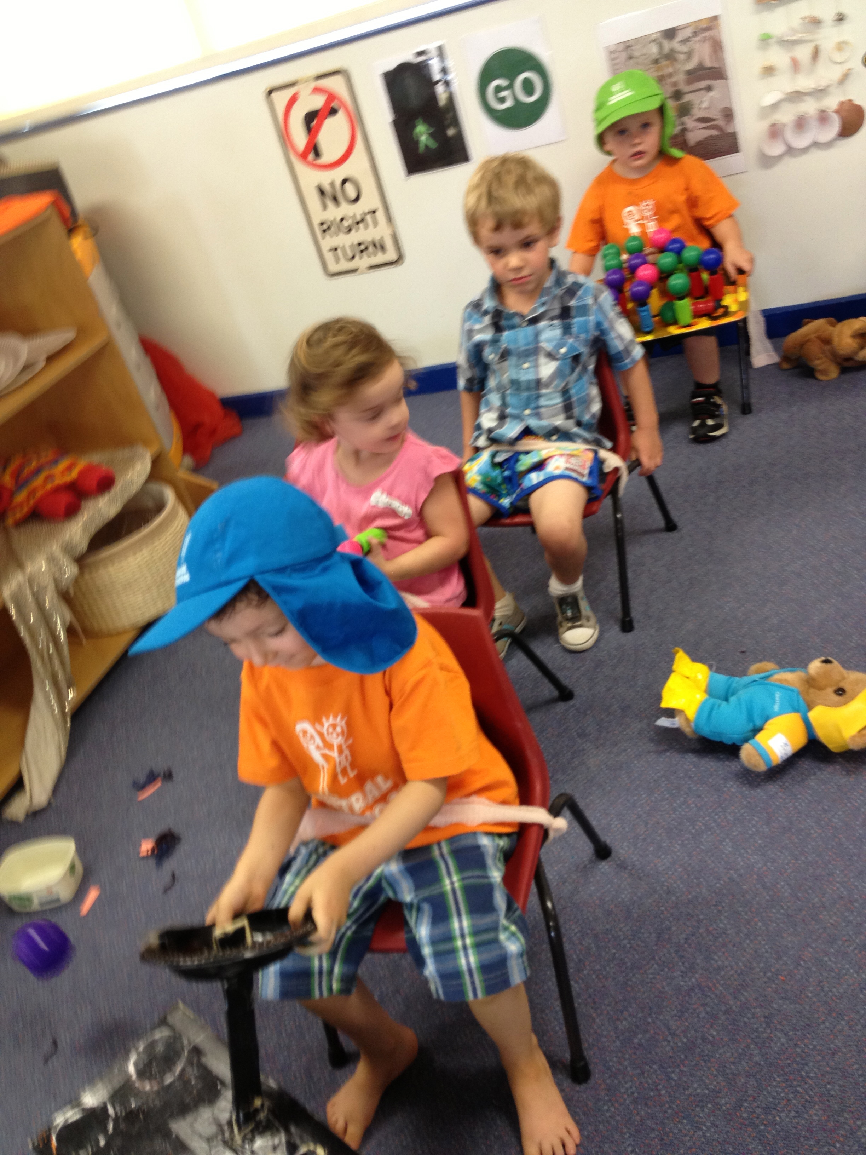
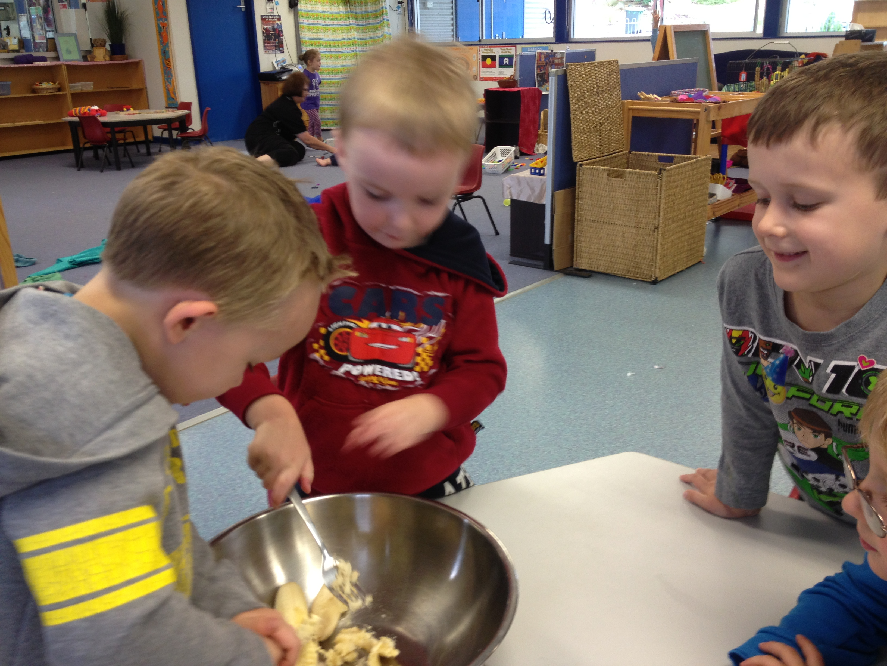
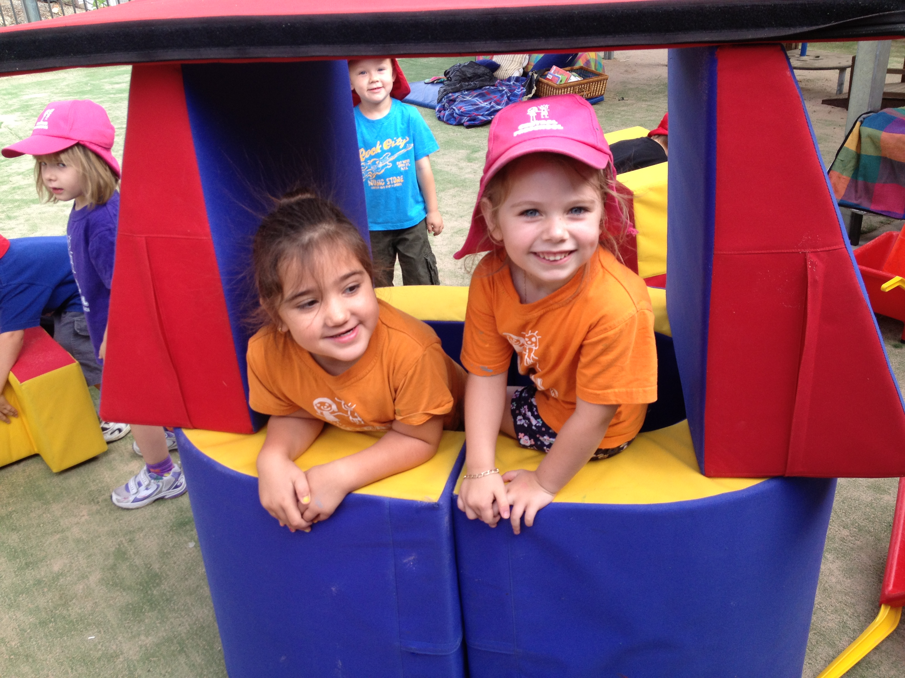
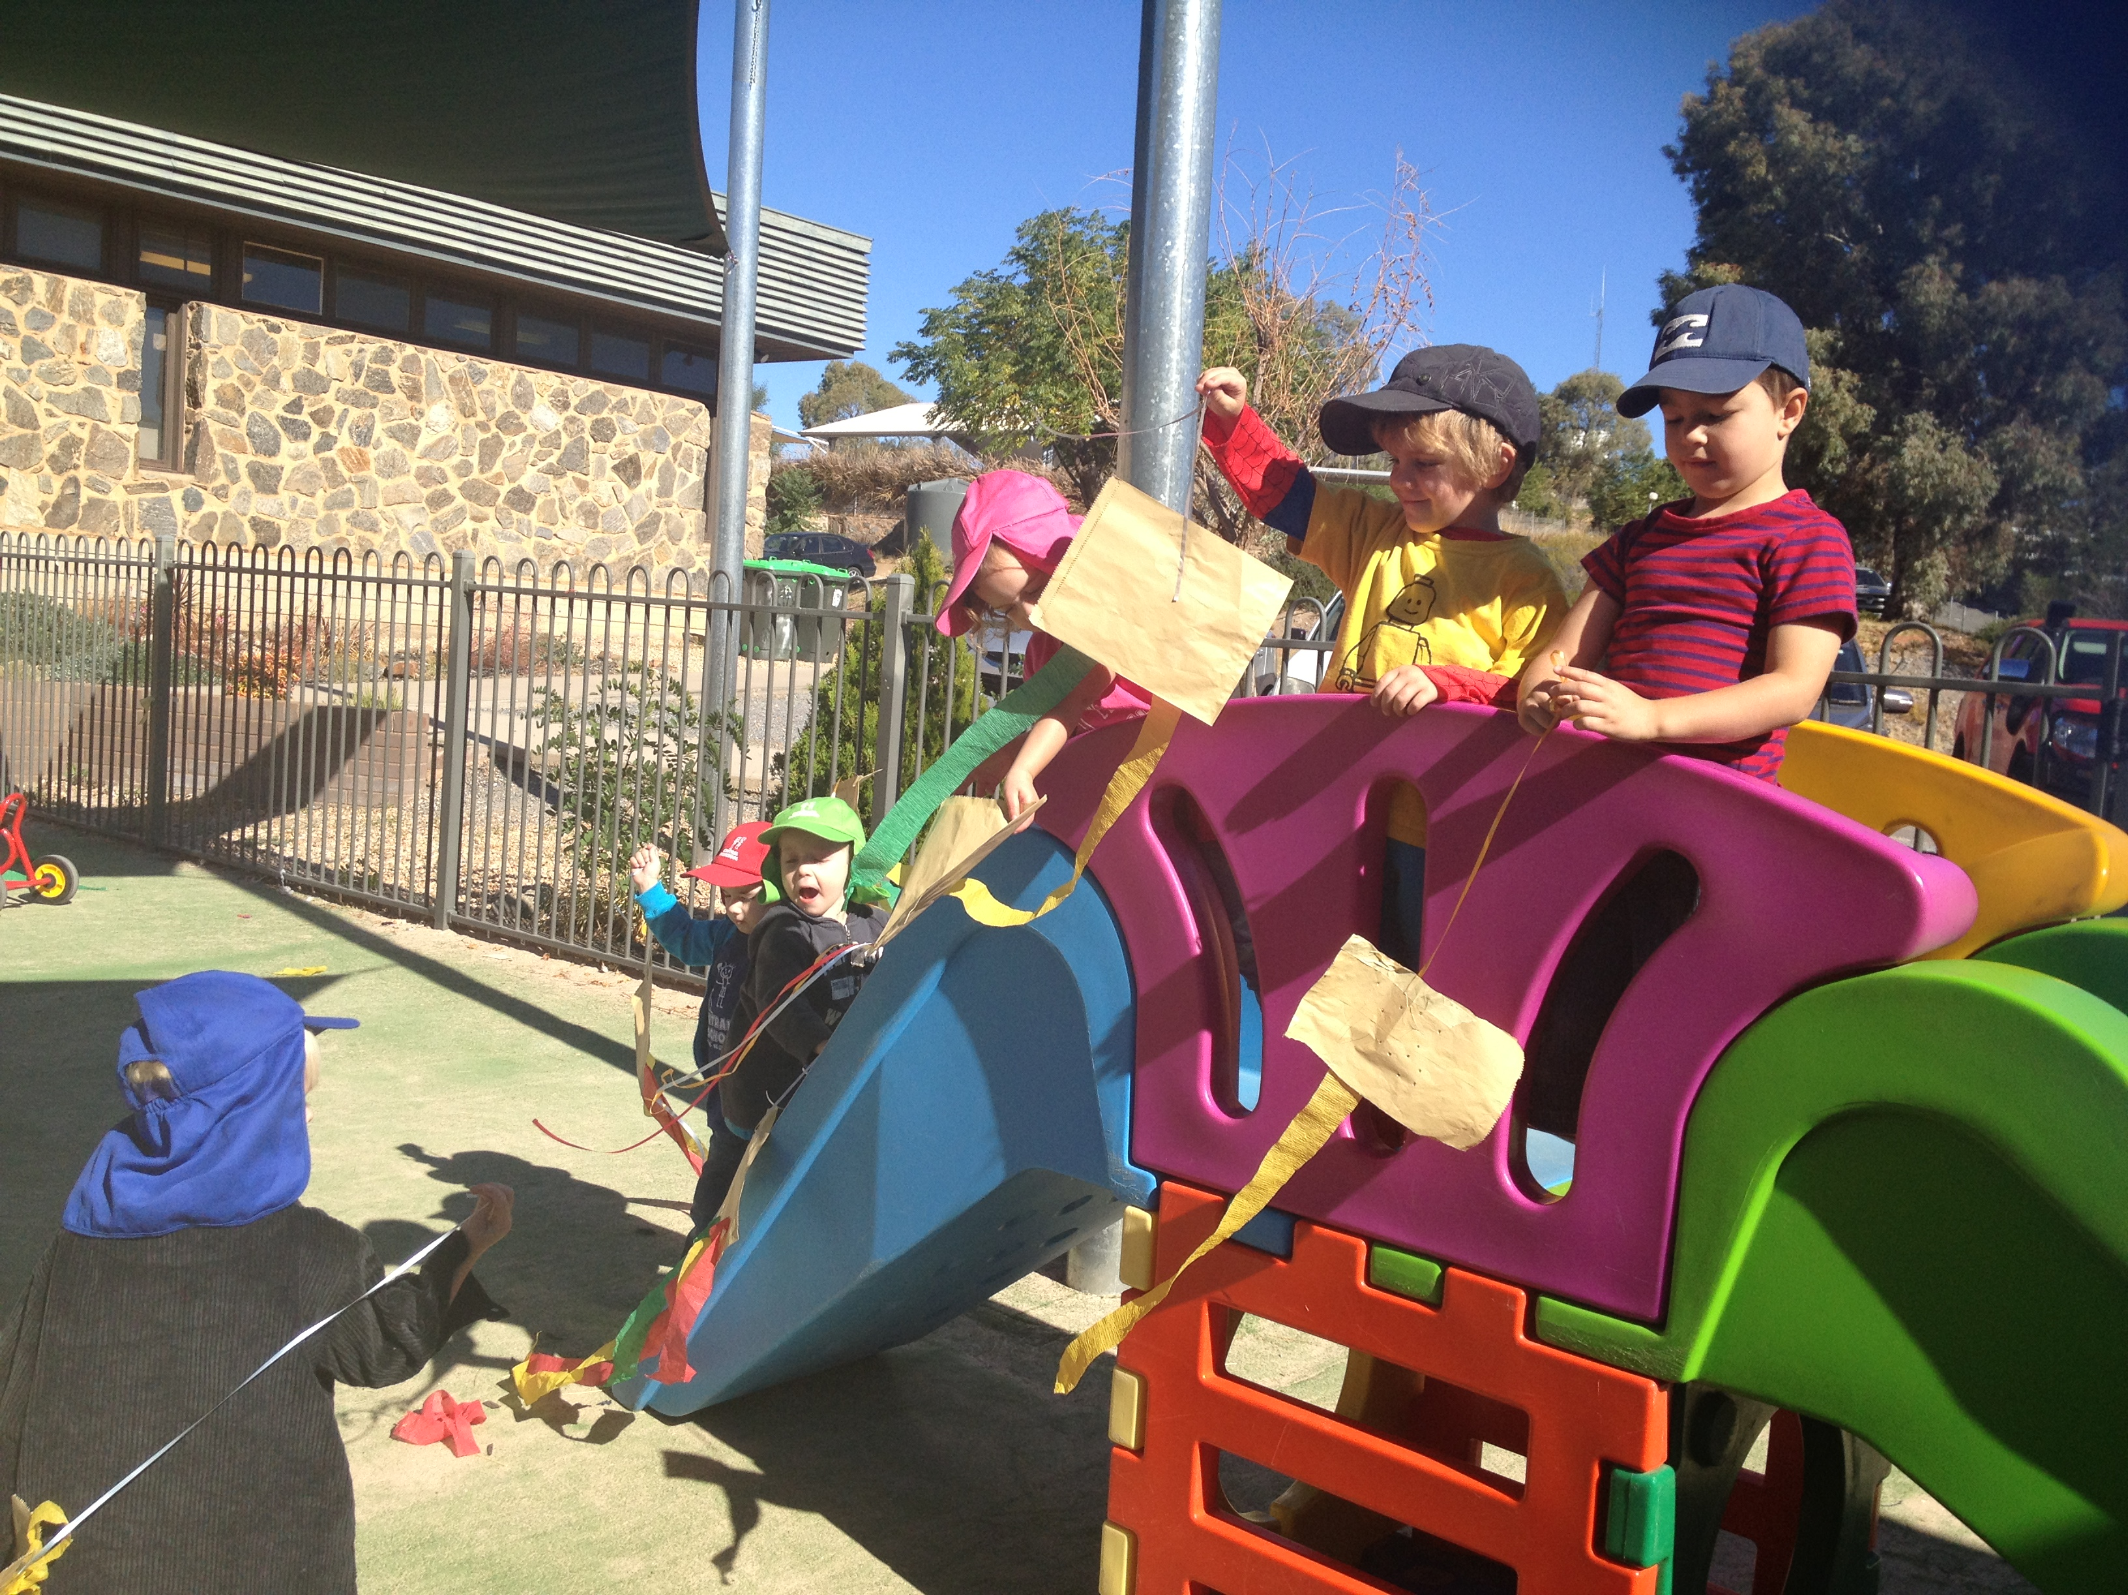
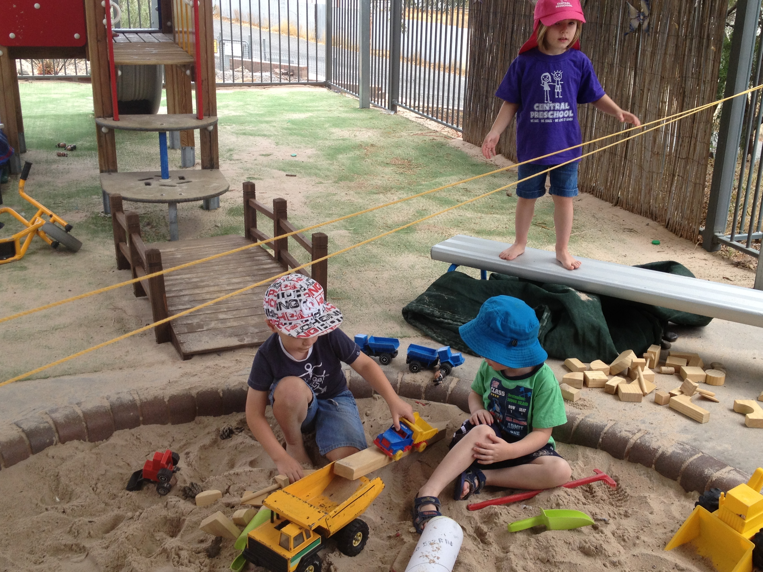
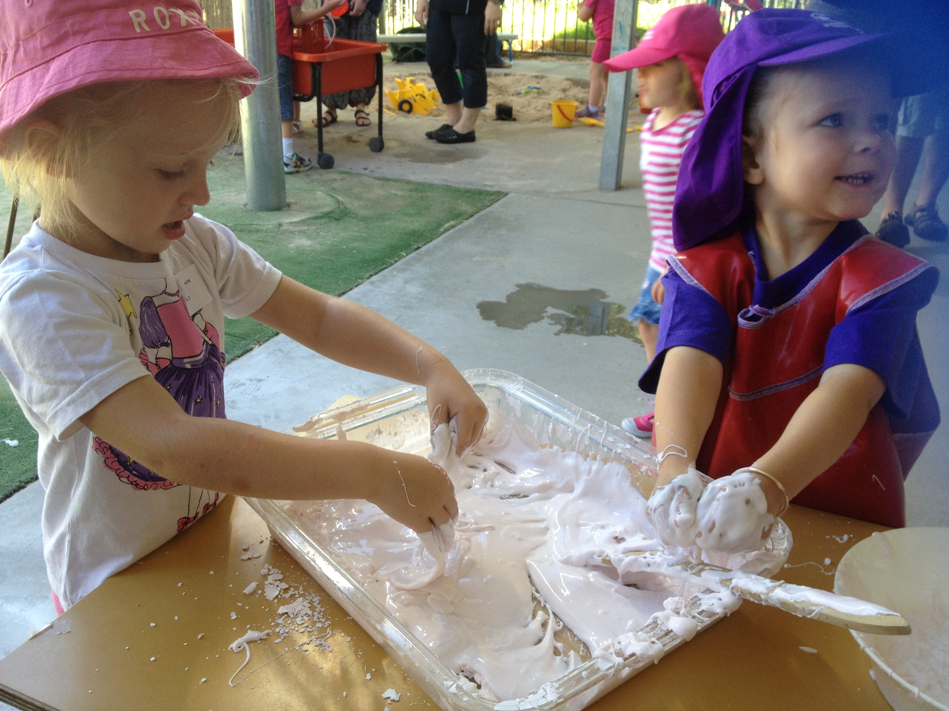
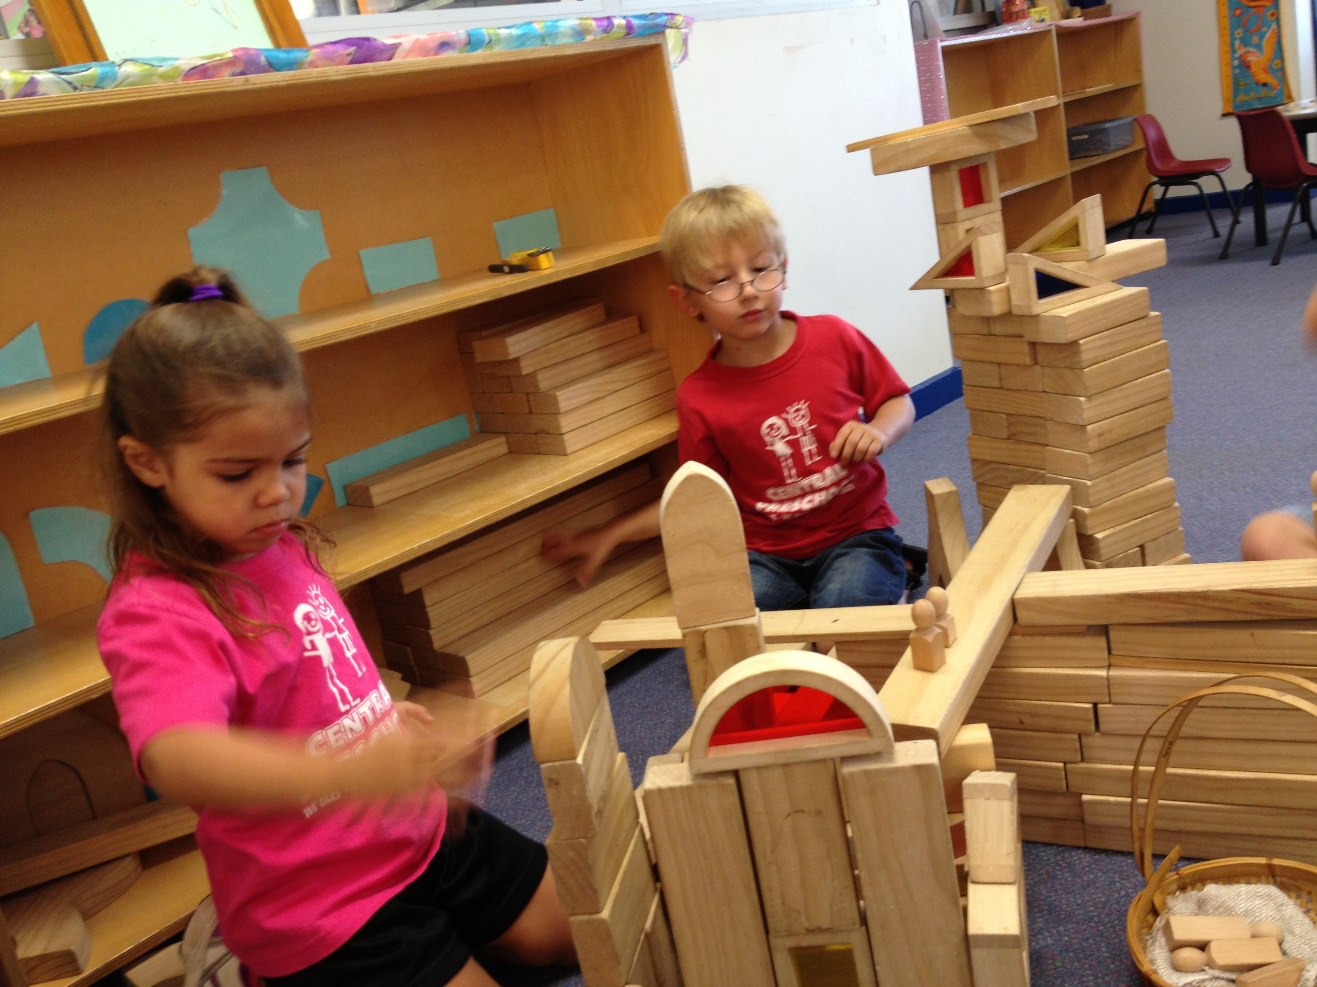
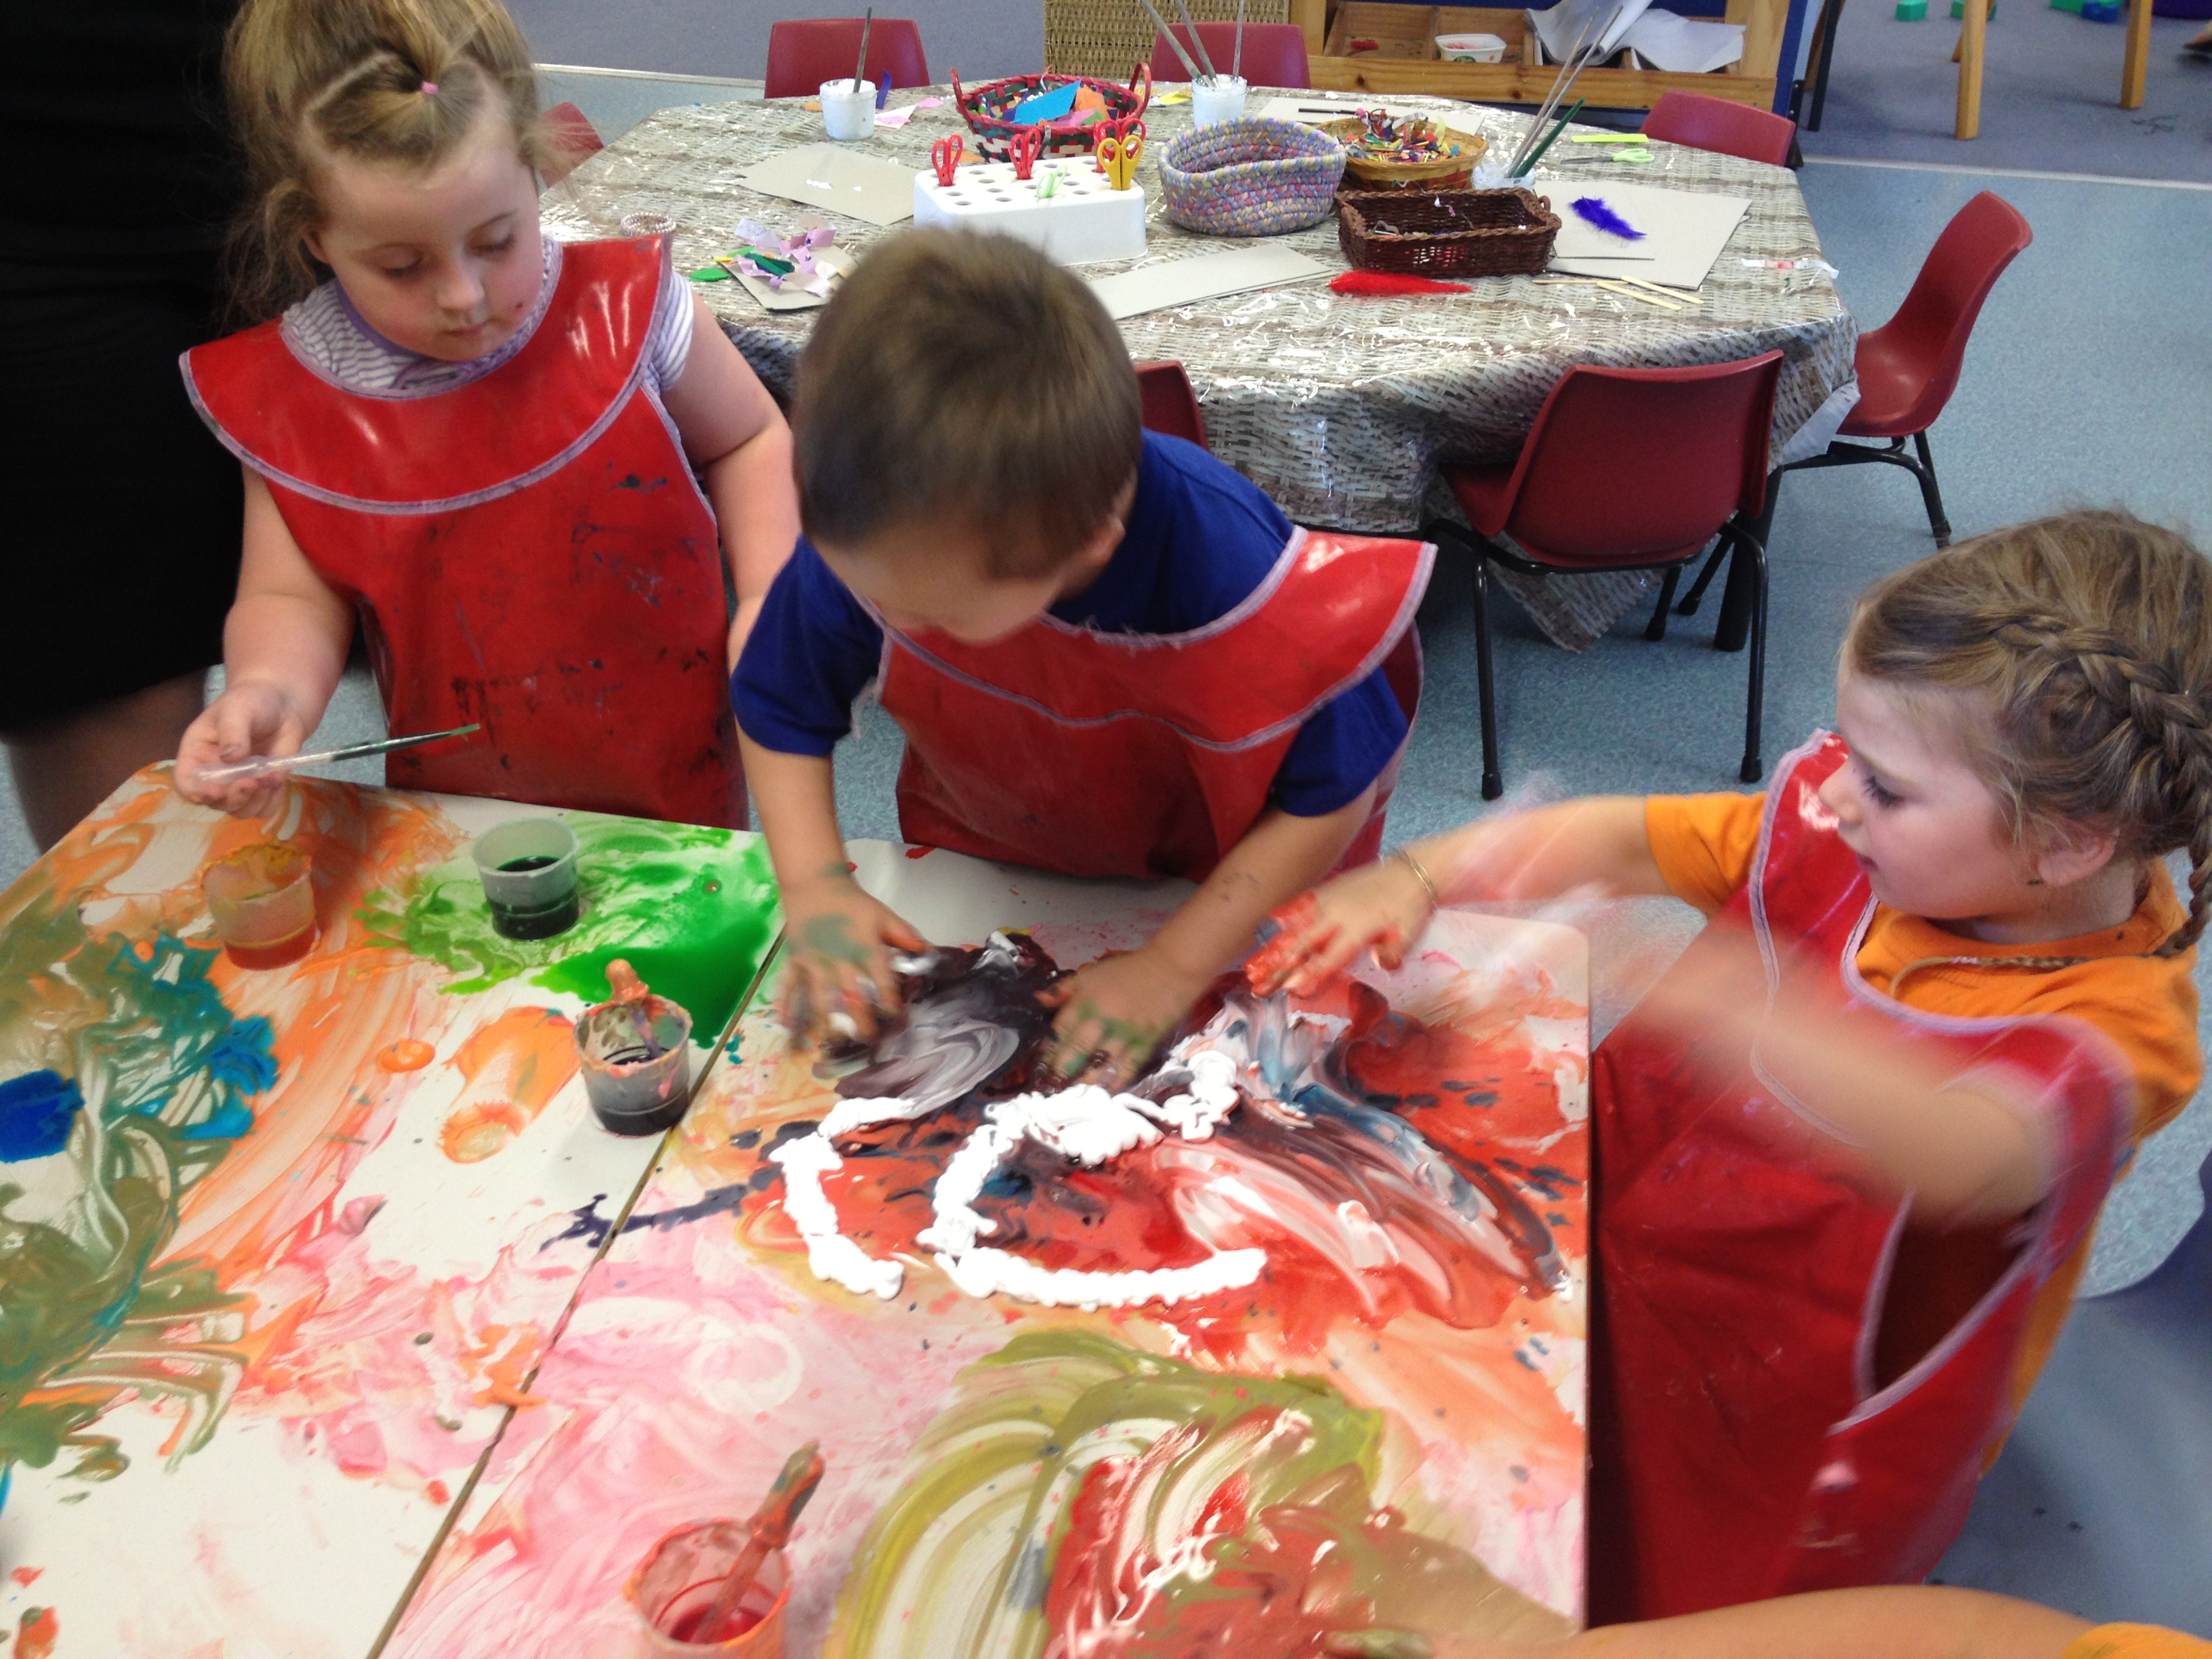
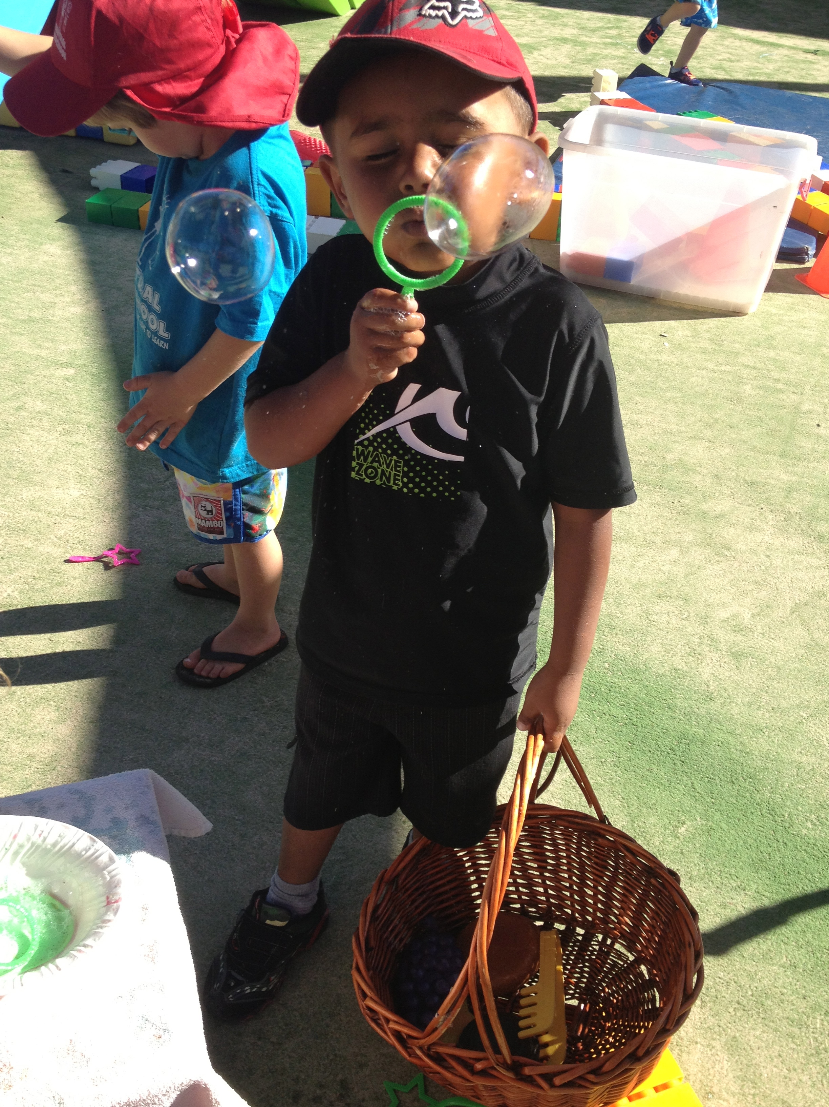
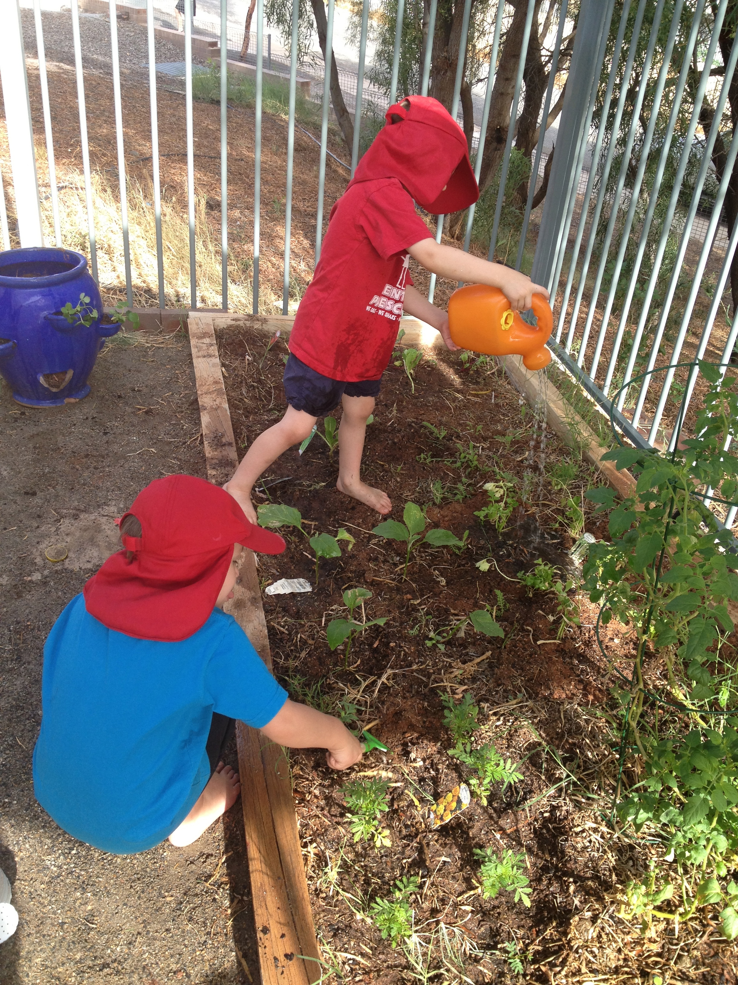
Broken Hill Public School
A dynamic school encouraging lifelong learning, integrity and success for all.
Welcome
to
Central
Pre School

We care, we share, we love to learn.

Being, Belonging, Becoming

Welcome to Broken Hill Public School Preschool (known as Central Preschool). We implement the Early Years Learning Framework (EYLF), a national early childhood curriculum framework which ensures quality and consistency in the delivery of early childhood programs, to guide our practice. Belonging, Being and Becoming refer to fundamental beliefs we hold about how children are best able to learn, grow and succeed at our Preschool. Belonging relates to connections and relationships with others. At Central, we work hard to build strong, supportive and collaborative relationships with children and their families. Being relates to our respect for your child to be a pre-schooler, with all the joys, opportunities and challenges the age brings to the learning space. We actively celebrate the way a pre-schooler makes sense of their world and participates in shared learning experiences. Becoming relates to the importance of the ongoing learning journey of each child and our role in supporting their transition from home to preschool and then to formal schooling next year or the year after. We welcome you to our preschool and look forward to working closely with you.

Our Belief

Children from birth are competent, capable and active contributors to their own and others’ learning. As educators we acknowledge each young child’s:
- uniqueness and complexity;
- capacity for self-direction and motivation;
- right to attachments and security, as a base for belonging, being and becoming;
- multiple relationships;
- abilities to form opinions and their right to express ideas and preferences; and
- connection to place.
Our educators extend children’s learning opportunities through intentional teaching and work with children in a reciprocal relationship where give and take is part of the mutual obligation of being together.

2014 Preschool Session Times

Session One (2 ½ days) Monday 8.45 am - 2.50 pm
Tuesday 8.45 am – 2.50 pm
Wednesday 8.45 am – 11.35am
Session Two (2 ½ days) Wednesday 12.00 pm – 2.50 pm
Thursday 8.45 am – 2.50 pm
Friday 8.45 am – 2.50 pm

Dates of Operation: School Terms only
(excluding Staff Development Days)

School Principal/Educational Leader: Mr Michael Fisher

Preschool Teacher/Certified Supervisor: Mrs Lyndal Walker

School Learning Support Officer: Miss Andrea Zammit

Phone: (08) 8087 3522 (School Admin Office) Fax: (08) 8087 3903 (School Admin Office)

Our Preschool Program: 3¹/₂ - 5 year olds

Our Preschool operates Monday to Friday with 2 alternate programs both offering the Federal Government mandatory 15 hours per week in the year prior to attending school for every child. Your child will be offered the program most suited to their needs after enrolment details are collected, considered and processed. (Please see attached waiting list application). Please do not assume enrolment, by submitting an application. Where working or other commitments, demand a preference, please indicate this on the waiting list application form.

Our program follows the National Early Years Learning Framework (EYLF) which has a strong emphasis on play-based learning. The framework recognises the importance of communication and language (including early literacy and numeracy) and social and emotional development. More information can be accessed at Australian Children Education and Care Authority (www.acecqa.gov.au).

The staff encourage children to enjoy a combination of planned play, as well as providing many opportunities for open-ended explorative play. Our classroom and outdoor environment are welcoming and well organised spaces. The learning centres are carefully arranged to promote active learning and are based on intentional and play based learning outcomes. Our program allows for flexibility and caters for the children’s emerging interests in all curriculum areas.

Play is seen as a crucial medium for learning and development. It acknowledges the child as capable and resourceful and allows the educators to follow the national guidelines, regulations and standards detailed in the National Quality Framework see www.mychild.gov.au for more information.

Our Principles, Practice and Outcomes

The Australian government has National Quality Framework Education and Care services National Law for Early Childhood Education and Childcare. The framework puts in place a new National Quality Standard across Australia. The National Quality Framework has 3 parts:
- the National Quality Standard;
- a national quality rating system with 5 levels including a quality rating for 7 key areas of childhood development; and
- the Early Years Learning Framework (EYLF).
We also ensure all staff working within our preschool adhere to the Early Childhood Australia Code of Ethics.

The five principles, which underpin our practise, are:

- secure, respectful and reciprocal relationships with children and families;
- partnerships with children, families, primary school and other professionals;
- high expectations and equity;
- respect for diversity; and
- ongoing learning and reflective practice.
Our practice is always:

- holistic;
- responsive to children;
- planned and play based;
- filled with opportunity for intentional teaching;
- considerate of physical and social learning environments, that have a positive impact on children’s learning;
- valuing the cultural and social contacts of children and their families;
- providing for continuity in experiences and enabling children to have successful transitions; and
- assessing and monitoring children’s learning to inform provision of and to support children in achieving learning outcomes.

The five learning outcomes we assess a child’s progress in/against and plan for are:

- children have a strong sense of identity;
- children are connected with and contribute to their world;
- children have a strong sense of wellbeing;
- children are confident and involved learner; and
- children are effective communicators.

Note: Each of these outcomes have several key components and subsections which are displayed in full in our Preschool, with our statement of philosophy and program overview.

A current program is always displayed in the foyer, along with children’s learning stories, upon which the planned program is based. The program is always evolving and we encourage you to spend time at pick up or drop off time to read about what we are up to during the week, and of course to talk to us about the program anytime. All family input is most welcome and encouraged, at all times.
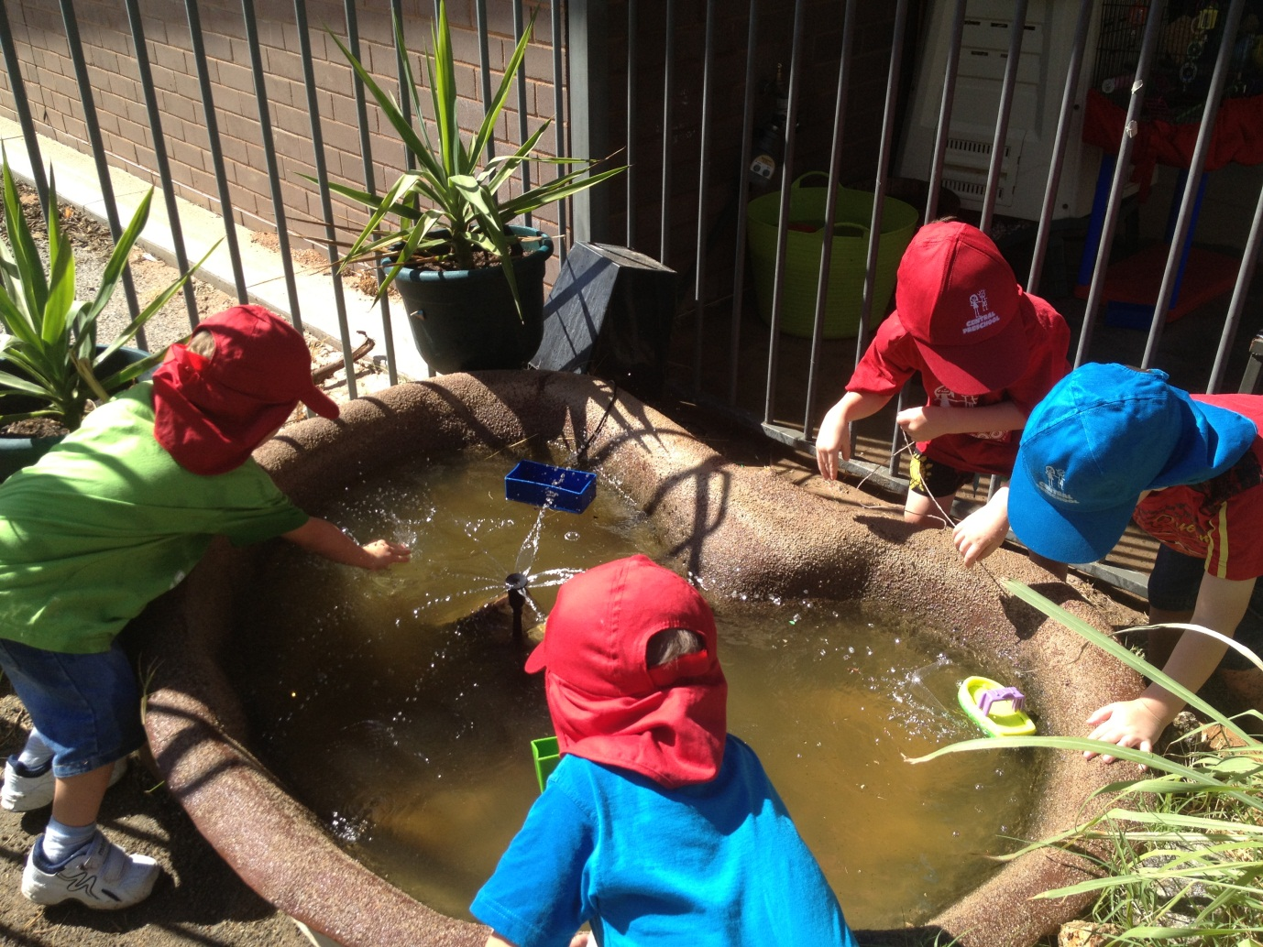

Use of School Facilities and Resources

As our preschool is part of Broken Hill Public School, we regularly use the school facilities, as well as offering a highly successful year long transition program. Some special links within our school include:
- visits to both the primary and infants playgrounds, throughout the year;
- participation in extracurricular activities and excursions on special days e.g. Teddy Bears’ Picnics, Easter Hat Parade, school fete, sports carnivals, Mother’s and Father’s Day activities;
- weekly library sessions in the school library, where children may borrow from a selection of books appropriate to their age and development, (beginning Term 2 annually);
- facilities for school banking which are available for all children to start their own savings account, which continues throughout primary school;
- school and preschool newsletters each week;
- assemblies and visiting performances;
- access to technology (eg. video conferencing and computer lab); and
- access to school dental, hearing, speech and occupational therapy services.

Complaints Handling

If you have any grievances about the care, protection and safety of your child, or the management of the preschool, please make an appointment with staff to raise these concerns. If you are not satisfied with the outcome, you can pursue your concerns further with the School Principal, Mr Michael Fisher.

Attempts will be made to resolve the grievance cooperatively and quickly, through discussion with the relevant parties and under the guidance of the School Principal.

Preschool Fees

The NSW government operates preschool classes in 100 government schools. From 2012, all government preschools will have a daily fee. All parents/carers are required to pay a fee for attendance. The full daily fee for our preschool class/es set by the NSW government is $15.00 a day. The policy clearly states that low income families (as determined by a current Commonwealth Health Care Card or Pension Card) are eligible for fee relief at the daily rate of $7.00. You can pay weekly, fortnightly, monthly or termly. The school will send an invoice to you, at the beginning of each term.

Under the policy, fee relief and fee exemption are always available. If you wish to discuss your family’s situation, it is important that you make the time to contact Mr Fisher our Principal, about any concerns you may have about your eligibility for fee relief, so that a more appropriate fee can be arranged for your child’s attendance at preschool. The policy clearly states that no child will be excluded from preschool in a public school because of the financial circumstances of their family.

Please be assured that any discussions that you and I have around these sensitive matters will always remain strictly confidential.

Any preschool fees collected by our school, will not be used for our preschool. Fees will be collected and forwarded directly to the NSW Government Treasury.

Excursions and Special Visits

Excursions are planned only when they directly relate to an area of interest in the program. Parents are invited to participate in excursions and will be notified in writing prior to these events. In-school excursions will be a regular occurrence and a signed permission note for the entire year is required (please see the Admin Office staff or the Pre School staff) some examples are: performances, the life education van and Questacon.

What your child needs to bring

- Morning tea, lunch, a piece of fruit for fruit break and a drink bottle with water only. No soft drink, cordials or fruit drinks.
- A complete set of labelled spare clothing (in a plastic bag) in your child’s bag, in case of little accidents or just as a result of water or messy play.
- A labelled bag or case. When buying this, ensure your child can manage to open and close it by him/herself and that it is large enough for all his/her belongings.
- A coat and hat in winter and a sunhat for summer (No hat, No play is the school and preschool rule).
- Library Bag (beginning Term 2).
- A yoga mat and small pillow – to be kept at preschool for the year.

Please note: Toys from home are not encouraged at preschool with the exception of ‘News’ items. A box for ‘News’ will be located in the kitchen. This restriction is due to our health and safety regulations and it also avoids loss and breakage of precious items.

Nutrition

At Central Preschool we have a morning tea break (recess) and a lunch break each day. In line with the whole school’s (P-6) fruit break/crunch n’ sip policy, we ask each child to eat their ‘fruit’ first at recess, before snacking on other items from their lunch box. Please try to provide a piece of fruit, fruit salad, vegetable sticks, yoghurt, cheese sticks or dried fruits as a priority each day. No nuts or nut products please. We have children with allergies that are life threatening.

We like to promote the development of healthy eating habits, as determined by NSW Health. We actively discourage lollies, chocolate, cakes, sweet biscuits, sweet drinks and chips, in favour of those listed above and rice snacks or cereal bars. The only exception to this is when we have special events such as birthdays, where a cake can be brought into share. Please don’t send peanut butter or nut products due to the possibility of allergic reactions. Please list the ingredients of all birthday cakes.

Special Occasions

The year is full of festive occasions. Parents are invited to join us for some of these, while others we celebrate within our classes. These include:

- Easter hat parade;
- Christmas parties;
- special school performances (In school performances);
- NAIDOC week celebrations;
- National Children’s Week celebrations;
- Mother’s and father’s day events;
- special assemblies, both whole school and infants assemblies; and
- school photos.

Dress Me – So I can get messy!

Staff will do their best to protect children’s clothing during art or other sensory play experiences. Parents and caregivers can also assist by dressing children in practical clothes for preschool, which can cope with the demands of an active day eg elastic top pants and easy wash fabrics.

Children’s clothes that become soiled will be placed in a plastic bag ready for parents to take home at the end of the day, to wash. All children’s clothing MUST be marked clearly for easy identification. A complete change of clothes is required for all children.

In accordance with the Department of Education and Communities Sun Safe Policy, children must wear a broad brimmed legionnaire or bucket hat, whenever they are outdoors (including winter). Our school has suitable hats, which can be purchased from the uniform shop (The Shed). On enrolment, each child receives a free hat and t-shirt from the school community. Children without hats in summer will play in shaded areas only ”No Hat, No Play”. The preschool will provide sunscreen for all children. If your child has an allergy to a particular sunscreen, please alert the preschool staff.

Suitable footwear is essential. We suggest shoes that are appropriate for climbing and easy for children to put on and take off (NO thongs, slip-ons and ugg-boots are allowed). Please label the inside of your child’s shoes for easy identification.

An Open Door for our Parents, Caregivers and Community Members

Our door is always open. We value ongoing communication and partnerships with parents, carers and community members. If there are specific issues or concerns, please feel free to make an appointment with the relevant staff. We are free to communicate daily at the end of your child’s session. Other means of communication include the school newsletter and a home-preschool journal to assist with links between family, home and school life. Please let us know the good and the not so great. It helps us improve our service delivery and keep “connected”.

Delivery and Collection of Children Policy

Central Preschool is committed to:

- the safe and orderly delivery and collection of children being cared for by the school;
- fulfilling its duty of care to all children;
- encouraging families to deliver and collect their children on time; and
- complying with all legislative requirements.

Sign-in Book

A book is provided near the entrance of the Preschool room. This book records the time and date that your child attends.

This book must be signed on arrival and departure of each day by the parent, guardian or the person who is authorised to collect your child.

If the adult who usually collects or delivers your child is not doing so on any occasion, this must be noted in writing and signed by the child’s parent.
Authorisation forms for temporary changes in collection are available next to the sign-in book, a copy is in this booklet and should be completed as necessary. Authorised persons must be over 18 years of age. No child will be released from our preschool without prior notice and the person being over 18 years of age. We value child safety and child protection.

Waiting List and Enrolment Forms

Parents seeking enrolment to Central Preschool must firstly fill out a waiting list application form. On the basis of the information given in this form, a decision will then be made regarding suitability for enrolment by the placement committee. Once accepted, parents must then fill out an Enrolment Form requesting details of custody orders, immunisation records and emergency contacts. Waiting List application forms will be kept for one year only. As vacancies occur, parents will be notified. A waiting list application form is included at the back of this booklet, however, the application does not give automatic enrolment. Please read the next page (page 9) for more information.

Access and Custody

The School Principal must be notified in writing of any legal requirements concerning access to your child and, where applicable, a copy of any Court Orders and instructions from your legal advisor.

Absent

If a child is absent from preschool, the parent/carer should inform the office by telephone or a letter stating the date and expected time period of the child’s absence. If the staff are not informed of the child’s absence after a period of two weeks, you will be notified that your child’s place may be filled by another on the waiting list, due to the long unexplained absence. Please do not assume that we know where your child is. A quick verbal explanation or note is all that is needed.

Enrolment of Children in Government Preschool Classes

The Department of Education and Communities (DEC) key focus is delivering educational services to school age children P-12. The department recognises the importance of preschool education. We are fortunate enough to have a DEC preschool on our school site. Children are eligible for enrolment in preschool classes from the beginning of the school year if they turn 4 years of age on/or before the 31 July in that year.

Applications for preschool enrolment are made by the parent/caregiver. Applications for the following year will be taken from Term 3 of the current year.

Where the number of children applying exceeds the number of places available, names will be placed on a waiting list. A prioritised waiting list will be established based on the DEC eligibility criteria. Priority of enrolment will be given in the following order/criteria.

- Low SES, Indigenous, families experiencing financial hardship, disability
- Children living within the local school boundary
- Children living outside the local school boundary who have siblings enrolled at the
school
- Children living outside the local school boundary

The waiting list application is valid for the year prior to enrolment in the preschool class and for the preschool year. If a vacancy occurs during the year, the position will be filled by the child with the highest priority on the waiting list.

Schools with DEC Preschools have a placement panel to consider and make recommendations on all enrolment applications to the preschool. The placement panel reviews each enrolment and all documentation on an individual basis, to place applications into priority order according to the stated eligibility criteria. Parent/Caregivers will be advised in writing of the placement panel’s decision regarding their waiting list application early in Term 4. If no response has been received from families that have been offered a position by the closing date, a phone call will then be made to ensure every opportunity has been made to contact parents/caregivers for these offers of placement. If no response has been received, the preschool position will be declared vacant and the panel will offer this to the next child on the priority waiting list.
Collection of Sick Children

As the preschool has no separate facilities to care for a sick child, it is important that any child observed to be unwell or with an infectious illness whilst at the preschool, must be collected by the parents/caregivers.

- Parents are required to collect their child as soon as possible after the preschool has requested, to ensure minimum stress on both the sick child and the other children. A written clearance from a Doctor is required for return to Preschool, in case of infectious disease.

Emergency/Evacuation Drills

An evacuation procedure is displayed in the preschool. Staff and children practice evacuation and containment drills on a regular basis (once a term).

Asthma

Every student with asthma attending the school/preschool should have a written Asthma Management Plan filled out by their family doctor or paediatrician, in consultation with the student’s parent/guardian. All staff will follow the Emergency Asthma Management Plan. For administration of asthma medication, please see below.

Administration of Medication

All preschool staff have training in administering prescribed medication. They will administer prescribed medication to children if requested to do so with written consent by parents/caregivers. The procedure is as follows:

- medication must be that which has been prescribed for the particular child and must be in the original container. The name of the child must be on the bottle. If medication is intended for siblings, the doctor must be asked to include all names on the label;
- written instructions about the medication must be supported by verbal consultation between parents and staff;
- parents must physically hand the medication to staff (i.e. it should NOT be left in the child’s bag);
- all medication must be checked by two staff members before being given. The person delegated to give medication must sign a medication authorisation form. This will then be co-signed by the second staff member;
- in the case of multiple medications being administered, a separate authorisation form must be used for each medicine to ensure the time and dose and medications do not get mixed up;
- on completion of a course of medication, the forms will be kept confidential in the child’s file; and
- medication must be stored safely out of the reach of children. Medication requiring refrigeration will be stored in the fridge, in a locked container.

Illness and Emergency Care Policy

The well being of children is of the highest priority in the preschool. We understand the concerns and needs of working parents and will try to accommodate the difficulties associated with a sick child. The teacher will keep all parents informed about the occurrence of an infectious disease in children, families or staff at the preschool – on the communication diary in the sign on area.

Infectious Diseases

To ensure a healthy environment, cross infection must be kept to a minimum. Parents must inform the preschool of any infectious disease in their family as soon as possible. Parents are required to keep their children home if they show any of the following symptoms.

- Diarrhoea: a child who has watery stools should not return to the centre until he or she has been free of the diarrhoea for 24 hours. If the child has an allergy or medical condition, which regularly causes diarrhoea, please discuss this with staff on enrolment.
- Vomiting: a child who is vomiting should be kept at home for a period of 24 hours, after the vomiting has stopped. Micro-organisms which cause vomiting and diarrhoea are highly contagious and will spread to others very quickly.
- Fever: (particularly if accompanied with nasal discharge): a child with fever of 38°C or higher must be kept at home and should be fever free for 24 hours before returning to the preschool.
- Head Lice (Pediculosis): the child should be treated at home. If head lice are detected when a child is attending the centre, parents will be notified to collect the child immediately. Recommended treatment must be applied without delay.
- Conjunctivitis: this eye condition requires specific medical attention and children may not return to the centre until 24 hours after medication is applied and the discharge has cleared. If a discharge reappears during the day, after a child has been treated, the parent will be required to collect the child and treat the eyes again.
- Cold sores/school sores: these conditions should receive specific treatment and sores should be covered.
- Hand Foot Mouth Infection: this is a highly contagious infection which consists of small lesions which tend to spread quickly on the side of the tongue or inside the mouth around the cheek region. Lesions may also occur on the hands, feet and occasionally on the buttocks. Children should not return to the preschool until they have recovered from the infection.
- Rashes: rashes may occur for a variety of reasons. You are requested to consult a doctor. Your child may attend with a medical certificate stating the rash is not infectious.
Please respect not only your child’s peers and staff, but their families as well. If you bring your child to preschool with a contagious ailment, it will spread. We aim to keep the preschool free of infections.
If you suspect your child may have an infectious illness such as measles, rubella or chicken pox, please have the condition diagnosed by a Doctor and notify staff, immediately. We thank you in advance for your cooperation in this matter.

CENTRAL PRESCHOOL - Authority to Collect

I give permission for my child to be collected from preschool on the days listed, by the person whose details are below:

Childs name: _________________________________________________
Dates: _______________________________________________________
or All year 
Collector’s Name: _____________________________________________
Address: _____________________________________________________
Phone: _______________________________________________________

_______________________________________ ________________________
Signature Parent/Caregiver Date

 - - - - - - - - - - - - - - - - - - - - - - - - - - - - - - - - - - - - - - - - - - - - - - - - - - - - - - - - - - - - - - -

CENTRAL PRESCHOOL - Authority to Collect

I give permission for my child to be collected from preschool on the days listed, by the person whose details are below:

Childs name: _________________________________________________
Dates: _______________________________________________________
or All year 
Collector’s Name: _____________________________________________
Address: _____________________________________________________
Phone: _______________________________________________________

_______________________________________ ________________________
Signature Parent/Caregiver Date

DEPARTMENT OF EDUCATION AND COMMUNITIES
No:
PRESCHOOL WAITING LIST APPLICATION

Family Name: ________________________________________________________

Child’s Given Name: ________________________________________________________

Child’s Preferred Name: ________________________________________________________

Sex: Male / Female

Date of Birth: ______________________________________________________________

Is your child currently enrolled in Broken Hill PS - Central Preschool? Yes / No

Is your child of Aboriginal and/or Torres Strait Islander origin? Yes / No

Home address: __________________________________________________________________

____________________________________________________________________

Mother/caregivers name: ________________________________________________________

Occupation: ____________________________________________________________________

Home telephone number: _________________________________________________________

Mobile telephone number: ________________________________________________________

Medicare number ______________________________ Health Care Card Yes / No

Father/caregivers name: __________________________________________________________

Occupation: ____________________________________________________________________

Home telephone number: ________________________________________________________

Mobile telephone number: _______________________________________________________

Medicare number ______________________________ Health Care Card Yes / No

Emergency Contact Name: ______________________________________________________

Home telephone number: ________________________________________________________

Mobile telephone number: _______________________________________________________

Relationship to family: __________________________________________________________

- Completing this form, does not automatically give your child/ren a place at Central Preschool. Please do not assume placement. This is a waiting list application only. All applications will be considered individually by the Placement Panel. All applications will be considered private and confidential.
Only for non-Australian Citizens

If your child is not an Australian citizen, what is his/her residency status?

_______________________________________________________________________________

If your child is a permanent or temporary visa holder. Please provide the following information:

- Current via class: _________________________________________________________

- Current visa sub-class: _____________________________________________________

- Visa expiry date: __________________________________________________________

Languages spoken at home

Does your child speak a language other than English at home? Yes/No

Main language: _________________________________________________________________

Other languages: _______________________________________________________________

Does your child have any specific needs? (eg. Disability, significant difficulty in
learning or behaviour, or a known history of violence).

If yes, please describe. __________________________________________________________

_______________________________________________________________________________

Does your child have any allergies or medical problems?

If yes, please describe. __________________________________________________________

_______________________________________________________________________________

Does your child currently attend another prior-to-school service? Yes / No

If yes, name of service: __________________________________________________________

Will your child attend another prior-to-school service in addition to this Department of
Education and Communities preschool? Yes / No

If yes, name of service: __________________________________________________________

Name of the school your child will attend in Kindergarten:

______________________________________________________________________________

- Completing this form, does not automatically give your child/ren a place at Central Preschool. Please do not assume placement. This is a waiting list application only. All applications will be considered individually by the Placement Panel. All applications will be considered private and confidential.
BROKEN HILL PUBLIC SCHOOL
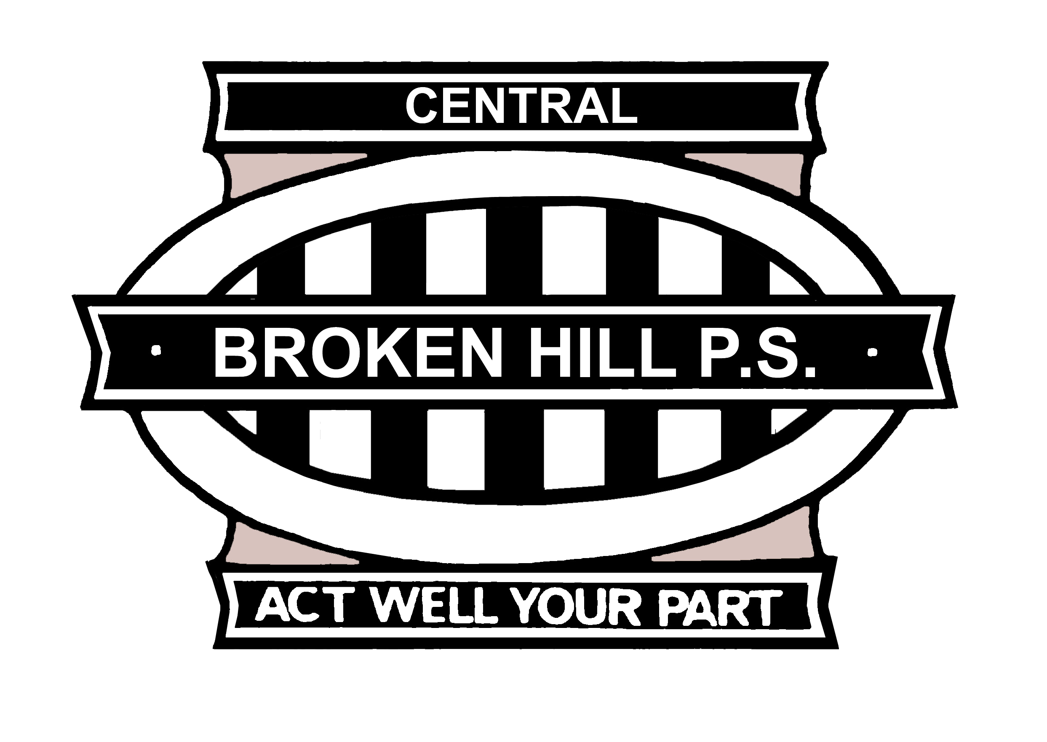
PRESCHOOL FEE RELIEF

Parent/Caregivers Name: __________________________________________________

Address: _______________________________________________________________

Child’s Name: ___________________________________________________________

 Health care card / Pension Card (photocopy attached)

Card Number ______________________________________________________

 Aboriginal / Torres Strait Islander

 Full fee exemption

 Fee relief reason ___________________________________________________

_________________________________________________________________

_________________________________________________________________

_________________________________________________________________

_________________________________________________________________

Full fee - $15.00 per day
ATSI - $7.00 per day
Health Care or Pension Card - $7.00 per day
30% Fee Relief - $4.00 per day
Full Fee exemption – $0.00 per day

Principal Recommendation ________________________________________________

______________________________________________________________________

Principal Signature: ______________________________ Date: __________________

- Completing this form, does not automatically give your child/ren a place at Central Preschool. Please do not assume placement. This is a waiting list application only. All applications will be considered individually by the Placement Panel. All applications will be considered private and confidential.
NAMES OF OTHER CHILDREN RESIDING WITH YOUR CHILD

 | GIVEN NAMES | FAMILY NAME | DATE OF BIRTH | SEX | NAME OF SCHOOL  (If applicable)
1
2
3
4
5
6

Making false or misleading declarations for material gain is an offence under Sections 25 and 25A of the Oaths Act 1900. I certify that the information given on these forms is correct.

Signature of Parent/Caregiver: ___________________________ Date:_______________

The personal information provided on this waiting list application form is being obtained for the purposes of processing your child’s application for possible enrolment in a preschool class at Broken Hill Public School Preschool. It will be used by the Department of Education and Communities for general student administration and communication purposes and other matters relating to the education and welfare of the child. Whilst the provision of this information is voluntary, if you do not provide all or any of this information it may delay or prevent the processing of this application for possible enrolment. This information will be stored securely. You may access or correct any personal information that you provided, by contacting the School Administration Office.

Office use only:

Date and time received: ____/____/____ Time: ______________

Birth Certificate, health care card or identity documents sighted and photocopied for file YES / NO

Proof of residence and immunisation details sighted and photocopies for file YES / NO

Passport or travel documentation for children who are not Australia citizens sighted and photocopied for file NA / YES / NO

Child’s Aboriginality and/or Torres Strait Islander status confirmed? NA / YES / NO

Year sought to attend Preschool: _________________________

